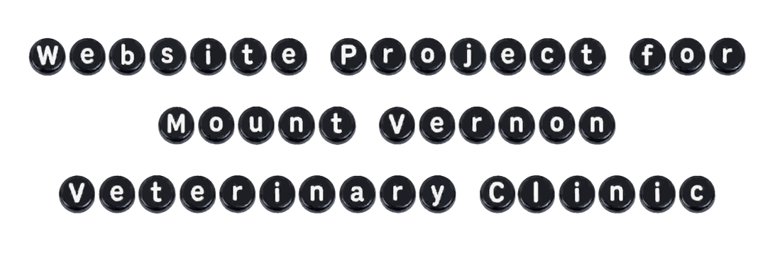

- The name of the organization and an overview of its mission.
  - Name: Mount Vernon Veterinary Clinic
  - Overview of its mission: To treat animals well and help them regain their health

- Explain why you chose this organization. Why is this organization important to you? How familiar are you with it?
  - Why did I chose this organization?
    - I chose it because I have always loved animals and wanted to do something that combines my interest in animals and programming. I thought creating a website for a veterinary clinic would be a great opportunity to support a local business while doing something I really like.
  - How familiar am I with it?
    - My parents have two cats and one dog, so I grew up around animals and am already familiar with caring for and interacting with pets.

- Include a description of the primary user and any secondary users. Why do they visit the site, and what do they hope to get from it?
  - Primary users (main target audience for whom the website is build):
    - Pet owners that want a veterinary service for their pet or want to shop their items
  - Secondary users (their needs are not the main reason the site exists, e.g. job seekers, suppliers looking for business terms, or volunteers, …):
    - Job seekers, pet brands for cooperations

- What type of data will your site collect from the visitors? List all of the form inputs
  - Name (first name, surname):
  - Adress:
  - Email address:
  - Phone number:
  - Message:

For further website building I would need:
- Introduction of the clinic/why chose this clinic
  - History
  - When it was founded
  - Philosophy
  - Opening hours
  - Google Maps with address
  - Phone, email
  - Emergency information
  - Logo
- Introduction to the team (maybe a team picture)
  - Years of experience
- Pictures of the location
- Services
  - Which animals
- Job opportunities
- Schedule an appointment

Questions for the clinic/Checklist:

Basic information
- Phone: +1 (319) 895-2300
- Email: mountvernonvet@gmail.com
- Opening hours: 8 am – 5 pm (Saturdays & Sundays closed)
- Social Media: just Facebook
- Logo:

About
- Mission:
- History:
- What makes the clinic unique?
- Animals treated: small pets, farm animals, no horses

Services
- List of services:
- Descriptions:

Team
- Names
- Job titles
- Photos
- Maybe: Short bios
- Maybe: Qualifications

Appointments
Just a contact form, no appointment schedule

Emergency
Do you offer emergency care?
What should clients do in an emergency?

Images of
Clinic exterior
Interior
Team
Animals
Treatments
Logo
Maybe: drone footage

Notes
Including Google Reviews
Google Maps link
External shop link
Different E-Mails, it should also have the same URL as the website
Example Website URL: mvvetia.com

